VNC Setup: Give Windows and Raspberry Pi Static IPs
Goal: Set fixed (static) IP addresses so you can reliably connect with VNC.
- Windows PC (Ethernet): 192.168.2.152 / 255.255.255.0
- Raspberry Pi (wired): 192.168.2.151 / 255.255.255.0 (/24)
- You’ll then connect in VNC Viewer to 192.168.2.151

Part 1 — Set a Static IP on Windows (Ethernet)
- Plug in Ethernet
  - Make sure your Windows computer is connected to the Pi (directly or via a simple switch) with an Ethernet cable.
- Open Network Settings
  - Click Start → Settings (gear icon).
  - Go to Network & Internet → Ethernet (make sure you pick the wired/Ethernet adapter you’re using).
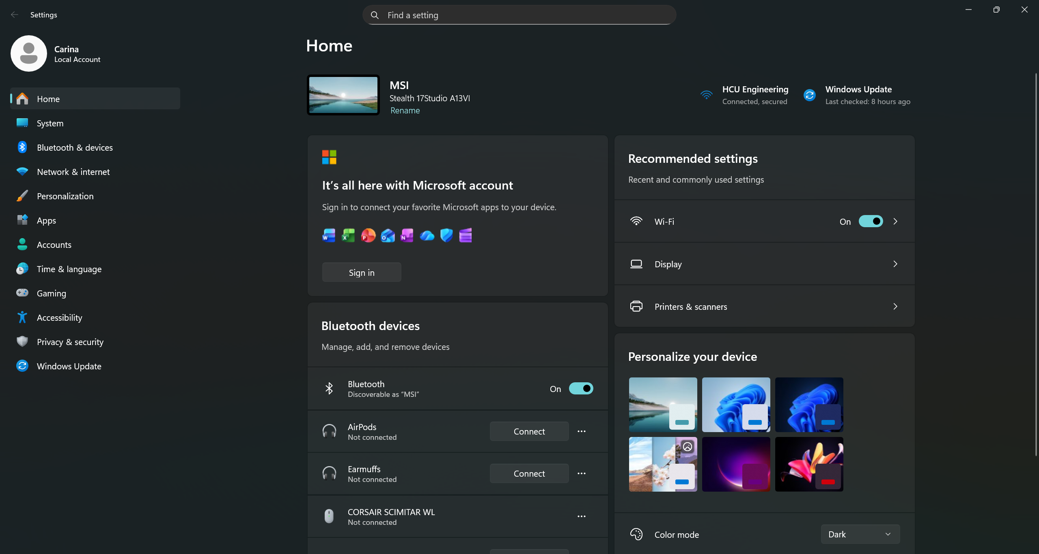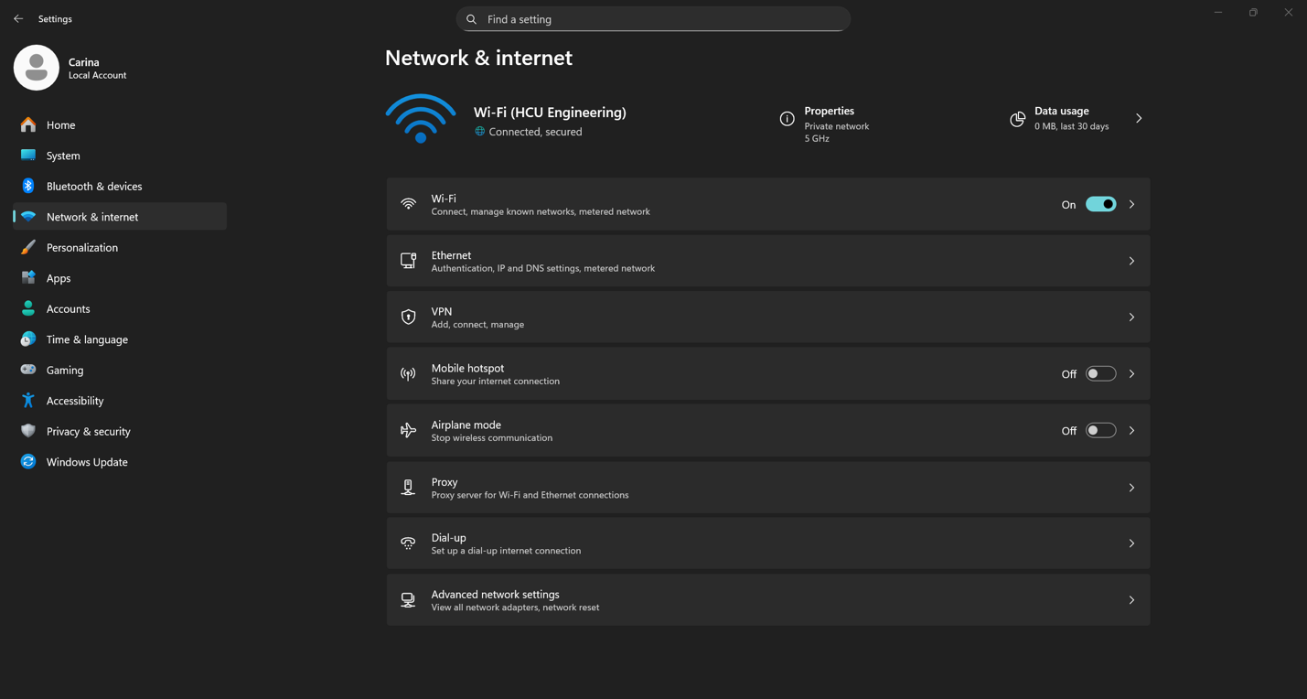
- Open IP settings
  - Scroll to IP assignment. Click Edit.
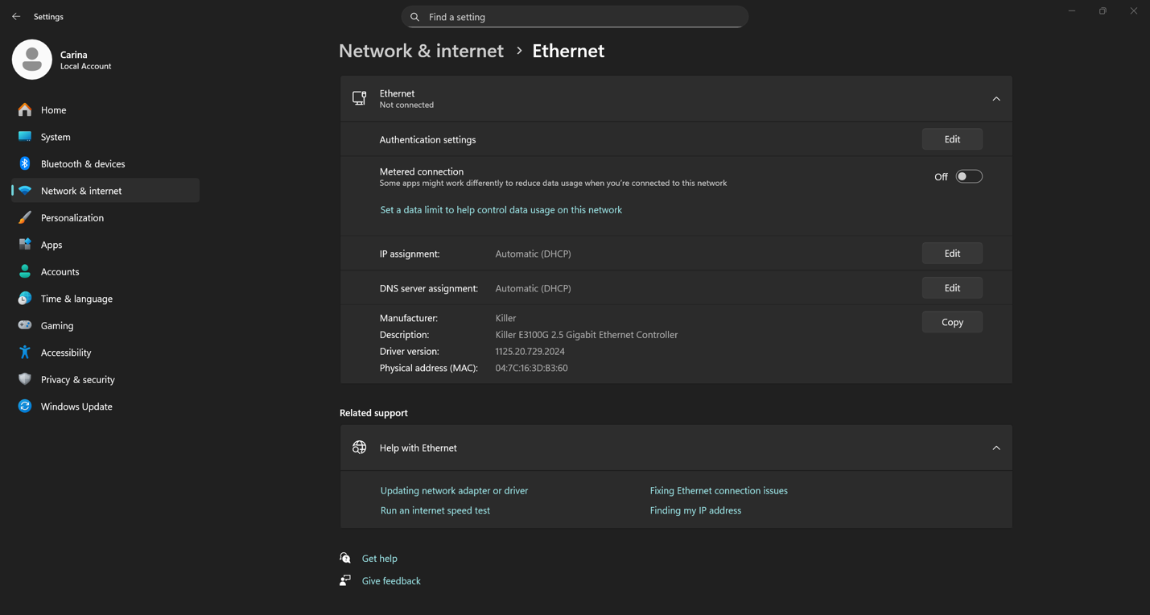
- Switch to Manual
  - In the dialog, change Automatic (DHCP) to Manual.
  - Toggle IPv4 to On (if it isn’t already).
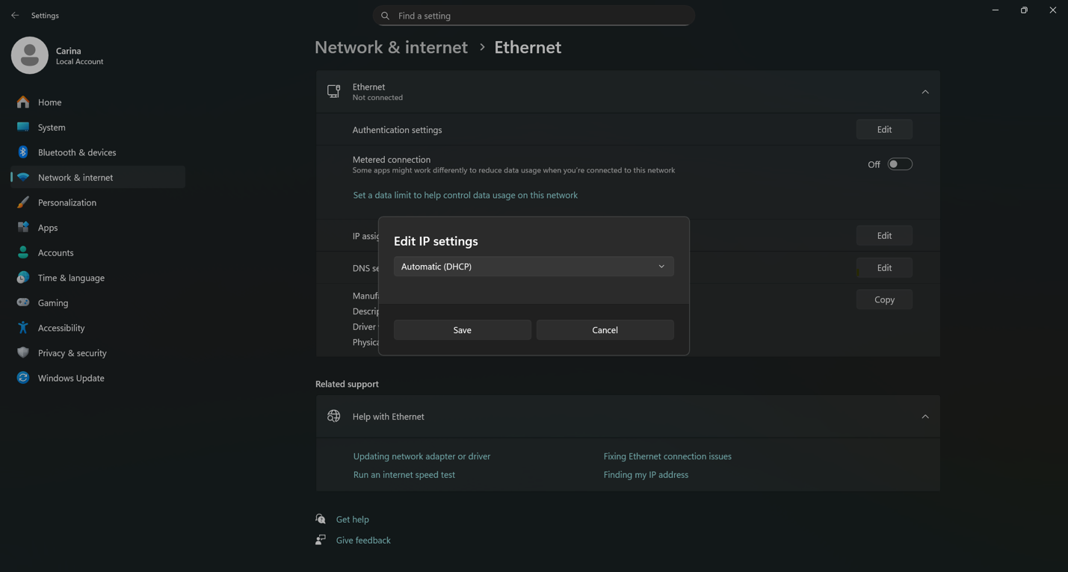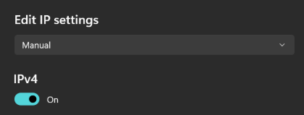
- Enter the Static Details
  - IP address: 192.168.2.152
  - Subnet mask (if shown instead): 255.255.255.0
  - Gateway: leave blank
  - Preferred DNS: leave
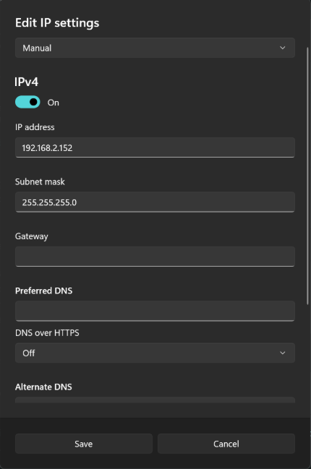
- Save
  - Click Save.
  - You should briefly see the Ethernet status change and reconnect.
- Quick Check
  - Press Windows Key → type cmd → open Command Prompt.
  - Type: ipconfig and press Enter.
  - Under your Ethernet adapter, confirm IPv4 Address shows 192.168.2.152 and Subnet Mask shows 255.255.255.0.

Part 2 — Set a Static IP on Raspberry Pi (wired)
You’ll do this first using the Pi’s current “.local” name, then switch to the static IP.
- Connect via VNC using the hostname
  - Open TigerVNC or RealVNC Viewer on Windows.
  - In the address bar, enter raspberrypi.local and connect.
  - If prompted, accept security prompts and log in.
- Open Network Connections on the Pi
  - On the Pi’s desktop, look at the top-right icons.
  - Click the two arrows (network icon) that may be blinking.
  - Choose Advanced Options → Edit Connections.
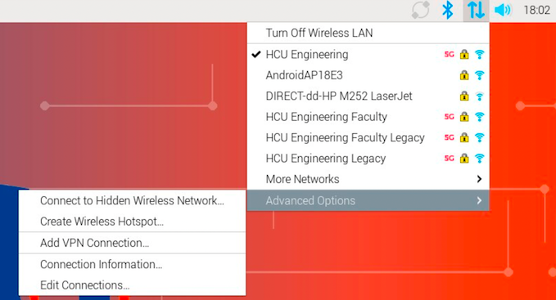
- Remove the HCU Engineering profile (if present)
  - In the list, select HCU Engineering.
  - Click the minus (–) button to remove it.
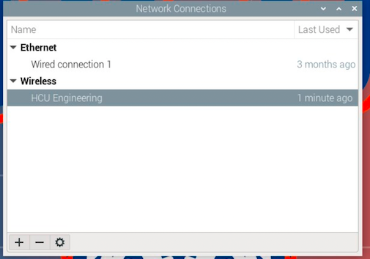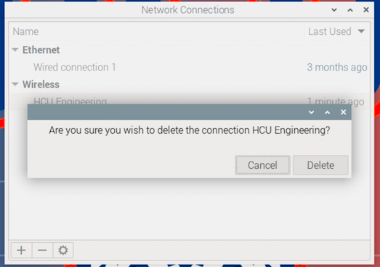
- Edit the Wired Profile
  - Select Wired connection (or similar wired profile).
  - Click Settings (or gear icon).
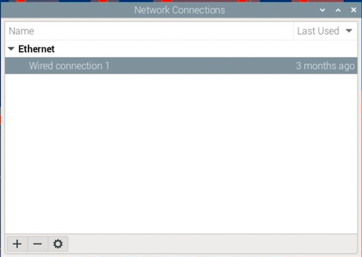
- Change IPv4 to Manual
  - Go to the IPv4 Settings tab.
  - Change Method from Automatic (DHCP) to Manual.
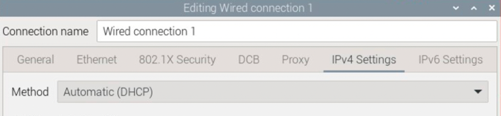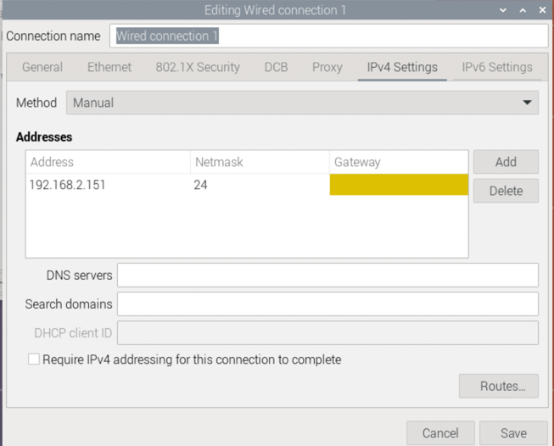
- Add the Static Address
  - Click Add (under Addresses).
  - Address: 192.168.2.151
  - Netmask: 24 (this equals 255.255.255.0)
  - Gateway: leave blank
  - DNS Servers: leave blank
  - Click Save.
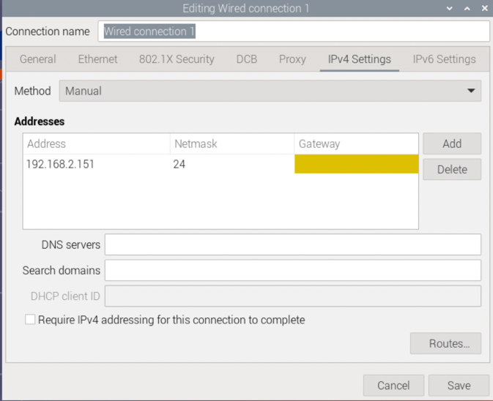
- Apply and Reconnect
  - Close the network windows.
  - It may take a few seconds for the new IP to take effect.
- Close your current VNC session
  - Close the VNC window you used for raspberrypi.local.
- Reconnect using the new static IP
  - Open your VNC Viewer again.
  - In the address bar, enter 192.168.2.151 and connect.
  - Log in when prompted.

Part 3 — Verify & Troubleshoot (quick!)
If anything doesn’t connect right away, try these in order:
- Ping test from Windows
  - Open Command Prompt and type:
ping 192.168.2.151
    - Success: You should see replies.
    - If it fails: Re-check that both devices’ IPs and subnet are exactly as above, and that Ethernet is connected.
- Confirm Windows IP again
  - ipconfig → look for IPv4 Address 192.168.2.152 and Subnet Mask 255.255.255.0.
- Confirm Pi IP locally (if you have keyboard/monitor on the Pi)
  - Open a Terminal on the Pi and run:
ip addr show eth0
    - Look for inet 192.168.2.151/24 on eth0.
- Make sure VNC is enabled on the Pi
  - On the Pi: Menu → Preferences → Raspberry Pi Configuration → Interfaces tab → VNC: Enable → OK.
  - If you had to enable it, try reconnecting in VNC after a few seconds.
- Cable/port check
  - Try another Ethernet cable or port if nothing else works.

